GameDev 2 – Final Project GDD

Fall 2021 | Shawna Zhou

Journey of Lux is a single-player 3D survival adventure game set in the year 4002. The world has been divided into light and dark due to the influence of social changes. In Light City, all things appear to be good and peaceful; while in the Dark City, everyone puts on armor to fight against the dark creatures in order to survive. The two cities fall under the same leadership called “The General”. Every first day of the year, The General selects two people from the two different cities to show them that the world is not only beautiful or simply rotten. This year, Lux is chosen with another girl from the Dark City. As a citizen of the Light City, she must try whatever it takes to survive the Dark City for 24 hours.

**Player Motivation/Experience:**

* I want the player to have an exciting experience with a moderate amount of challenge. I want the player to feel free enough to explore the world but also enough excitement to defeat monsters.

**Game Structure:**

* Single-player
* The main challenge in Dark City is to stay alive from the hungry creatures. The creatures will attack the player if in range.
* The player can chat with NPCs in the world.
* The player can not exit Dark City or exceed the world boundaries.

**Narrative:**

* The game is set in the Dark City. The Dark City is located on the bottom half of the habitat. This city gets no sunshine and no peace. There are blood-thirsty creatures everywhere along with humans who slaughter them to live.
* Lux is the main character in this game. She is a citizen of Light City. She is a young adult who was chosen to be exchanged to the other world on the first day of the year. She has never been to the Dark City before nor does she know anything about this place.
* The player plays as Lux in the game.

**Core Mechanic:**

* Shooting. Lux carries a rifle to protect herself from the monsters. Player left click to shoot.
* Conversation. Lux can speak to NPCs and learn more about this world.

**Other Mechanics:**

* Gathering items. There is loot generated in the world which the player can pick up to use. Such as potions and medkits.
* Ability move. Lux has a special ability called Knife Dance which allows her to shoot knives in a circle to damage enemies.

GAME SYSTEMS OVERVIEW

Written System Description:

* **Lux (protagonist)** 
  + Attribute
    - Body: 3D objects with collision NavmeshAgent
    - Position: the beginning of the scene (lower corner)
    - Health, Inventory, Ability, healthbar

Behavior

* + - Attack: kill creatures
    - Ability: cast character ability
    - Adjust inventory
    - Walk: explore the environment
    - Use: use item in inventory
    - Talk: chat with NPCs
* **Dark City Assassin**
  + Attribute
    - Body: 3D objects with collision
    - Unity AI - navmesh agent
    - Position: East of the map
  + Behavior
    - Chat: talk to the player
    - Responds to different choices.
* **Time Counter** 
  + Attribute
    - Sprite: image
    - Position: left top on the screen
  + Behavior
    - Count-down: count a certain time and display it to the player.
    - End game: end the game when time is up.
* **Score Counter** 
  + Attribute
    - Text and Score Script
    - Position: left top on the screen
  + Behavior
    - Display kill count it to the player.
    - End game: calculate the player score
* **Creature (black)** 
  + Attribute
    - Body: 3D objects with collision
    - Rigidbody
    - Unity AI Navmeshagent
    - Position: in the open terrain area
  + Behavior
    - Detect Hunger level
    - Detect Player
    - Chase Player
    - Attack Player
    - Escape from Player
    - Heal self
    - Deal damage
* **CreatureS (red)**
  + Attribute
    - Body: 3D objects with collision
    - Rigidbody
    - Unity AI Navmeshagent
    - Position: in the open terrain area
  + Behavior
    - Detect Player
    - Chase Player
    - Explode as touching the player
    - Deal damage
* **Weapon (Gun)** 
  + Attribute
    - Weapon Blocks cubes
    - Default weapon that shoots
    - Bullets
      * Rigidbody
      * Collider
    - Position: On Lux
  + Behavior
    - Attack monsters with projectiles
      * Launched from fire point
* **Potion** 
  + Attribute
    - 3d objects with collision
    - Item in Inventory
    - Position: randomly procedurally generated
  + Behavior
    - Give the player a speed boost
* **MedKit**
  + Attribute
    - 3d objects with collision
    - Item in Inventory
    - Position: randomly procedurally generated
  + Behavior
    - Heal Player HP by 15.

Systems Diagram

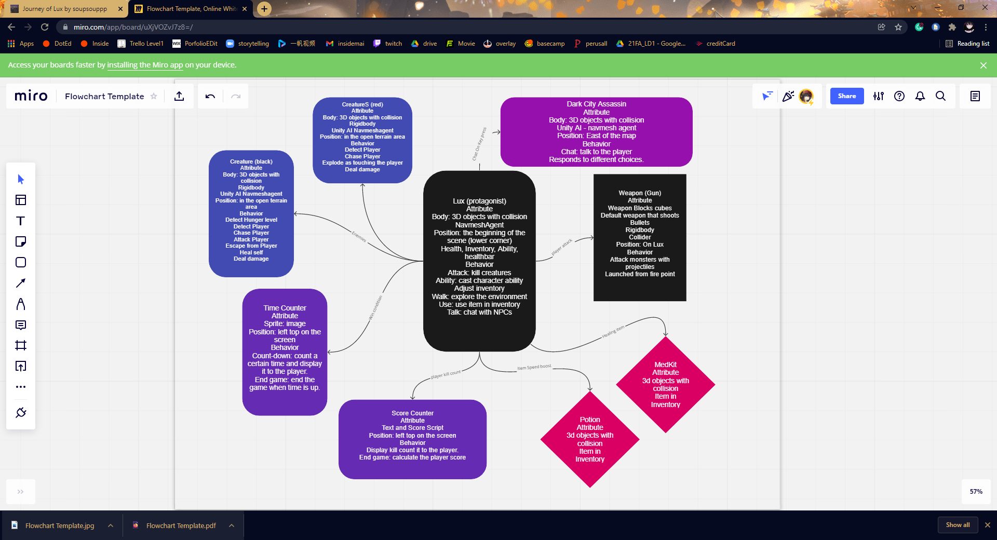

PROJECT REQUIREMENTS

AI

* The creatures in the Dark City have AI. The black creature uses the information around them (in their range) to decide if they want to perform different actions. Such as, the enemy will chase the player if the player gets too close, attack the player if possible. The creature also escapes to their safe spot after their health drop low. They will stay at the safe spot and heal themselves until they are healthy again, then goes back to the player.
* The red creature detects the player in a shorter range, once the player gets in range it runs to the player at a high speed then explodes if touching the player - dealing damage.

Procedural Generation:

* The loot is procedurally generated to be placed on random areas of the map. When the level loads it will provide the player with some items such as potions and medkit.
* The potion is located more towards the edges of the map, and the medkits are mostly spawned towards the middle ground.
* The player can then pick up the loot and use it to benefit their gameplay. This adds certain randomness to the game.

C# and Unity API:

* Using collision to calculate and make a damage system.
  + Bullets using rigidbody to hit
  + Creature deal damage upon collision
* Using arrays to make an inventory system
  + Adjust and hold different items
  + Use current idem in hand
* Enum to set AI States
  + Multiple AI state machines to help AI decide what to do
  + 7+ states
  + Enemy spawning
* If else and nested loops to control the AI
  + Nested loops included
  + Help AI prioritize certain behaviors before others
* Using script to create NPC that can respond to different choices
* Activation canvas on Keypress
* Using a script to give character stats and abilities
* Reference scripts in each other to create interactions